Given Waveform

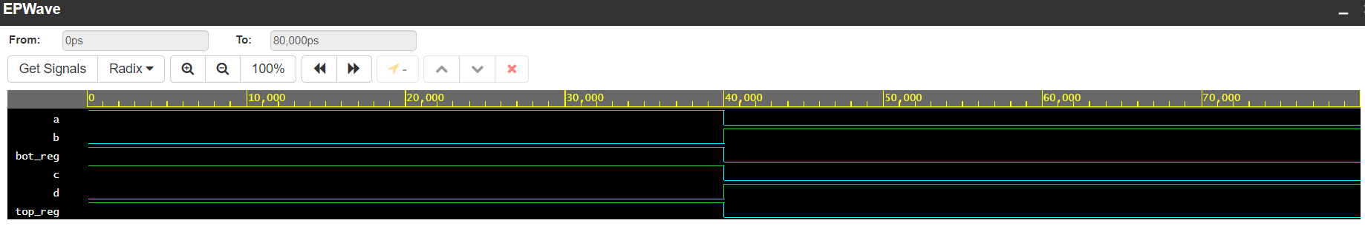

Final waveform

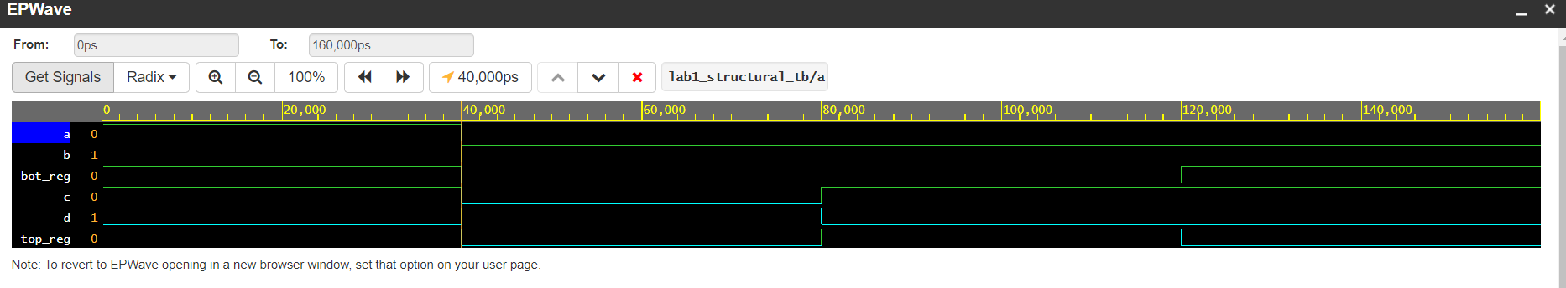

Yes, for the added 2 test cases the final waveform looks correct based on the outputs that I calculated.

For the first 2 test cases the inputs were either 1 for the top and bottom or 0 for both the top and bottom, which corresponded to the outputs in the format of abcd b1010 for t1b1 and b0101 for t0b0

For t1b0 I calculated the output to be 0110, which was the same as the output for t0b1.

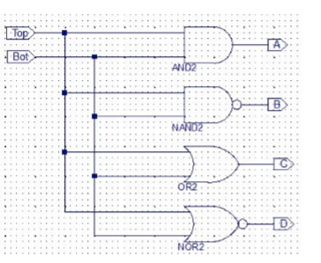this is because, based on the image of the design given in the lab manual, the order of the inputs do not matter because the gates are all in parallel. Which made test cases 3 and 4 the same despite top and bottom having different values

For the order of the cases that we have in the code, it is apparent that we implemented it correctly because it corresponds to the waveform that the program as generated

For top register in cases 1,2,3, and 4, the order of the values was 1,0,0,1 and for the bottom register the order alternated between, 1,0,1,0

The difference between 2 and 4 test cases was in the segments or steps for the wavelengths